**2022**

**Peermade, Kerala** – **685 531**

**Marian College Kuttikanam Autonomous**

**Reg. No:22pmc129**

**Jarina Devasia**

**BY**

**MAHATMA GANDHI UNIVERSITY, KOTTAYAM**

**OF**

**MASTER OF COMPUTER APPLICATIONS (MCA)**

**FOR THE AWARD OF THE DEGREE**

**OF REQUIREMENT**

**A PROJECT REPORT SUBMITTED IN PARTIAL FULFILMENT**

**Music Streaming Website**



**2022**

**Peermade, Kerala** – **685 531**

**Marian College Kuttikanam Autonomous**

**Reg. No:22pmc129**

**Jarina Devasia**

**BY**

**MAHATMA GANDHI UNIVERSITY, KOTTAYAM**

**OF**

**MASTER OF COMPUTER APPLICATIONS (MCA)**

**FOR THE AWARD OF THE DEGREE**

**OF REQUIREMENT**

**A PROJECT REPORT SUBMITTED IN PARTIAL FULFILMENT**

**Music Streaming Website**



**2022**

**Peermade, Kerala** – **685 531**

**Marian College Kuttikanam Autonomous**

Marian College Kuttikkanam Autonomous

PG Department of Computer Applications

Assistant Professor

Ms. RENY JOSE

**Under the guidance of**

**Reg. No:22pmc129**

**Jarina Devasia**

**By**

**MAHATMA GANDHI UNIVERSITY, KOTTAYAM**

OF

**MASTER OF COMPUTER APPLICATIONS (MCA)**

**FOR THE AWARD OF THE DEGREE**

**SUBMITTED IN PARTIAL FULFILMENT OF REQUIREMENT**

**Music Streaming Website**

A Project Report on



**External Examiner**

**External Examiner**

Marian College Kuttikkanam Autonomous

Marian College Kuttikkanam Autonomous

PG Department of Computer Applications

PG Department of Computer Applications

Assistant Professor

Head of the Department

**Ms. Reny Jose**

**Mr Win Mathew John**

During the academic year 2022-2023

**MASTER OF COMPUTER APPLICATIONS [MCA]**

In partial fulfillment of the requirements for the award of Degree of

**Reg. No:22pmc129**

**Jarina Devasia**

is a bonafide record of work done by

“Music Streaming Website”

This is to certify that the project work entitled

**CERTIFICATE**

**KUTTIKKANAM** – **685 531, KERALA.**

**MAHATMA GANDHI UNIVERSITY, KOTTAYAM**

**Marian College Kuttikkanam Autonomous**

**PG DEPARTMENT OF COMPUTER APPLICATIONS**



Jarina Devasia

internal guide Ms.Reny Jose who provided all her services at any time as a guidance for this project.

my friends who support me to complete this project and at last but not the least I wish to thank my

First of all I want to thank my parents for giving an opportunity to study in this college and i thank

**Acknowledgement**



It is a system that allows users to explore and listen to a wide variety of songs available on the music streaming website. The project consists of different genres and categories of music, and they are displayed in an organized manner. The user can browse through these songs and add their favorite songs to their personal collection. If the user finds a song they like, they can listen to it instantly. Once the user subscribes successfully, they gain access to a wide range of songs and exclusive content. Thus, the online music streaming project brings a comprehensive music library to users' fingertips, making it convenient and enjoyable for music lovers to discover, listen, and enjoy their favorite tunes.

ABSTRACT MUSIC STREAMING WEBSITE

**TABLE OF CONTENTS**

Chapter Page No

1 Introduction 1

1.1 Overview of Project 2

2 System study 3

2.1 Existing system 4

2.2 Proposed system 4

3 System Analysis 5

3.1 Requirement Specification 6

3.2 Requirement Definition 6-7

4 Functional Requirements 8

4.1 Module Specification 9-10

5 Non Functional Requirements 11-12

8 Future Enhancement 13-15

9 Conclusion 16-17

10 References 18-19

11 Appendix 20-25

**1.INTRODUCTION**

* 1. **OVERVIEW OF THE PROJECT**

The online music streaming website is developed in such a way that allows users to check for various songs available at the online website and lesson them online. The project consists of list of Songs displayed in various categories. The user may browse through online. If the user likes a song he/she can add it to favourites. Thus the online music streaming project brings an entire song lessoning system online and makes it easy for both visitors and regular users.

The customers can register and login to this site. And after the lesson to music they can logout from the site. To lesson again, they need to login with the username and password already created.

**2.SYSTEM STUDY**

**2.1 EXISTING SYSTEM**

2.1 EXISTING SYSTEM

The previous system of music streaming websites was limited in terms of features and user experience. It involved manual purchasing of physical music media such as CDs, DVDs, or vinyl records from music stores. The old system had the following characteristics:

* Physical Media
* Limited Selection
* Inconvenience
* Lack of Flexibility
* Limited Information
* No Personalization
* Lack of Interactivity
* Inability to Preview or Sample Music

**2.2 PROPOSED SYSTEM**

The proposed system aims to revolutionize the old system of music streaming by introducing an online platform that provides a seamless, personalized, and interactive music streaming experience. The key features and advantages of the proposed system are as follows:

* Online Access
* Extensive Music Library
* User Profiles and Preferences
* Advanced Search and Filtering
* Sample and Preview
* Offline Mode

**3.SYSTEM ANALYSIS**

**3.1 REQUIREMENT SPECIFICATION**

**HARDWARE SPECIFICATION**

Processor :INTEL CORE 13 7 GEN

RAM :8GB RAM

Hard Disk Drive :100MB

Keyboard :Standard 103 keys

Processing speed :2.66GHz

Memory size :256MB

Cache memory :256KB

Storage :1GB 3.6.3

**SOFTWARE SPECIFICATION**

Front End :Python

Back End :SQLite

Operating Syste :WINDOWS 10

**3.2 REQUIREMENT DEFINITION**

Requirements Analysis is the process of defining the expectations of the users for the website that is to be built or modified. The goal is to produce a document of the client's requirements and fulfill their needs. This document forms the basis of development and software validation. It involves all the tasks that are conducted to identify the needs of different stakeholders.

**ADMIN**

* Admin can add songs, delete songs and update songs.
* Can see the details of available songs.

**CUSTOMER**

* Customer can view and lesson the songs.
* Customer can add songs as favorites.
* Can lesson songs both online and offline.

**4.FUNCTIONAL**

**REQUIREMENTS**

**4.1 MODULE SPECIFICATION**

1. User Authentication Module:

- Registration: Users can create an account by providing their username, email, password, and confirm password.

- Login: Registered users can log in using their username and password.

2. Artist Module:

- Add Artist: Admin can add new artists to the system by specifying their name.

- View Artists: Users can view a list of artists available in the system.

3. Song Module:

- Add Song: Admin can add new songs to the system by providing the title, artist (selected from the existing artists), audio file (uploaded from the user's device), and optional thumbnail image.

- View Songs: Users can browse and view a list of songs available in the system.

- Song Detail: Users can view detailed information about a particular song, including the title, artist, and thumbnail image.

4. Category Module:

- Add Category: Admin can add new music categories to the system by specifying the name, description, and optional image.

- View Categories: Users can browse and view a list of music categories available in the system.

5. Favorites Module:

- Add to Favorites: Users can add songs to their favorites list by clicking on a "Favorite" button associated with each song.

- View Favorites: Users can view their list of favorite songs.

6. Search Module:

- Search by Title: Users can search for songs by their title, displaying matching results.

- Search by Artist: Users can search for songs by artist, displaying matching results.

- Search by Category: Users can search for songs by category, displaying matching results.

**5.NON FUNCTIONAL**

**REQUIREMENTS**

**5.1 NON FUNCTIONAL REQUIREMENT**

* **Performance Requirement**

System Should be Error-free.

Large amount of data should be handled easily.

* **Safety Requirement**

Backups can be done regularly.

* **Security Requirement**

A password is given to the SQL server. Administrator and the end user, who have their own user name and password. Have only the right to open the software.

**6. FUTURE ENHANCEMENT**

**6.1 FUTURE ENHANCEMENT**

The music streaming website has a wide scope for future enhancements and improvements. The current system, developed using Python and SQLite, serves as a solid foundation for further advancements. Here are some potential areas for future enhancements:

1. Multiple Admins: The system can be modified to allow for multiple administrators who can manage different aspects of the music streaming website. This would distribute the workload and enable better control and coordination.
2. Multiple Stores: In the future, the website can be expanded to include multiple stores, each offering a unique collection of songs or genres. This would provide users with more options and a diverse music library to choose from.
3. Enhanced User Experience: The user interface can be further improved to enhance the overall user experience. This may include incorporating intuitive navigation, personalized recommendations based on user preferences, and interactive features such as song ratings and reviews.
4. Social Integration: Integrating social media features can enhance user engagement and sharing capabilities. Users can connect their social media accounts, share their favorite songs or playlists, and discover music based on their social network's recommendations.
5. Advanced Search and Filtering: Implementing advanced search and filtering options will allow users to find songs based on various criteria such as artist, album, genre, release year, and more. This would make it easier for users to discover new music and explore their favorite genres.
6. Playlist Management: Enhancing the playlist management feature will enable users to create and manage personalized playlists. They can save, edit, and share their playlists with others, creating a more personalized and interactive music experience.
7. Integration with Music APIs: Integrating with popular music APIs, such as Spotify or Apple Music, can expand the music library and provide users with access to a vast collection of songs from various sources.
8. Mobile Application: Developing a dedicated mobile application for the music streaming website would extend the service to mobile users, allowing them to access and enjoy music on the go.
9. Personalized Recommendations: Implementing machine learning algorithms and data analytics techniques can enable personalized song recommendations based on users' listening history, preferences, and behavior patterns.
10. Payment Integration: Integrating secure online payment methods would allow users to subscribe to premium features, purchase songs or albums, and support their favorite artists through the platform.

**7.CONCLUSION**

**7.1 CONCLUSION**

The proposed system for the music streaming website aims to revolutionize the way users access and enjoy music online. By automating key operations and providing a user-friendly platform, the new system addresses the limitations of the old system and offers a more convenient and secure music streaming experience.

The registration module plays a crucial role in the proposed system, allowing users to create accounts and gain access to a vast collection of songs. User information will be kept confidential to ensure privacy and security. The website aims to provide users with a consolidated platform where they can explore a wide range of music genres and artists in a convenient, impressive, and visually appealing manner.

With the new system, customers can browse and search for songs at any time, from anywhere in the world. The system offers a diverse selection of songs, and users can make purchases or subscribe to premium features with ease. The streamlined online music shopping experience eliminates the need for physical visits to music stores and offers a higher level of privacy. Users can explore song details and listen to previews without disclosing personal information.

The proposed music streaming website enhances the overall accessibility, convenience, and privacy of online music streaming. It provides a platform for users to discover new music, create personalized playlists, and enjoy a seamless listening experience. By leveraging technology and continuously improving the system, the music streaming website aims to stay up-to-date with the latest trends, meet user expectations, and provide an exceptional music streaming service.

In conclusion, the proposed system for the music streaming website brings significant advancements and improvements to the old system, offering users a modern, efficient, and enjoyable way to access and experience music online.

**8.REFERENCES**

**1).** [**https://open.spotify.com/**](https://open.spotify.com/)

**2).** [**https://www.youtube.com/**](https://www.youtube.com/)

**3).** [**https://www.w3schools.com/html/**](https://www.w3schools.com/html/)

**11.APPENDIX**

**REGISTRATION PAGE**

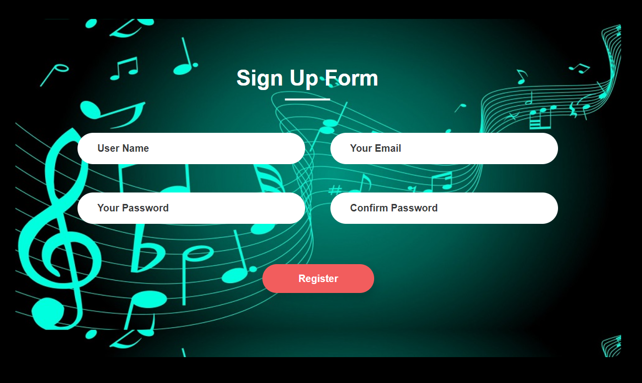

**LOGIN PAGE**

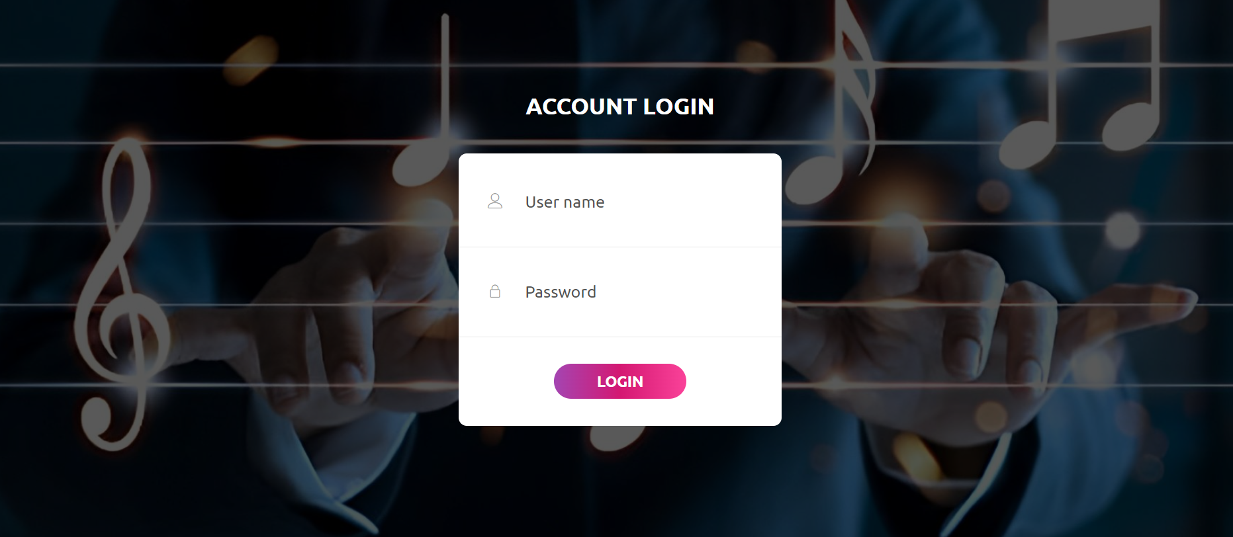

**ADMIN PAGE**

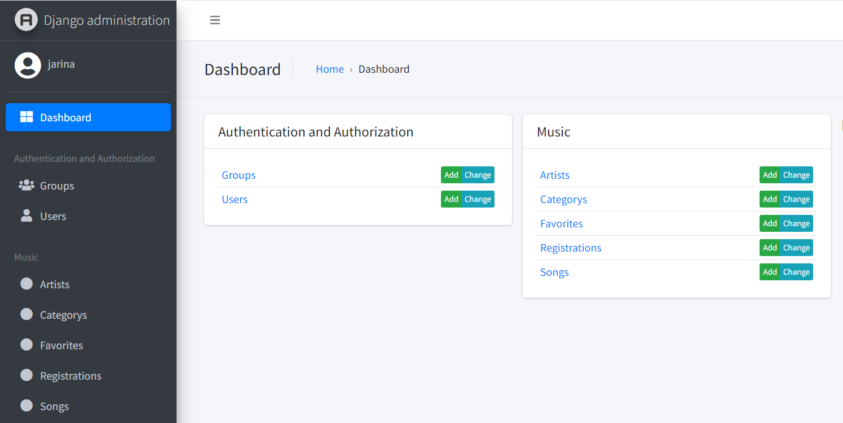

**LATEST PAGE**

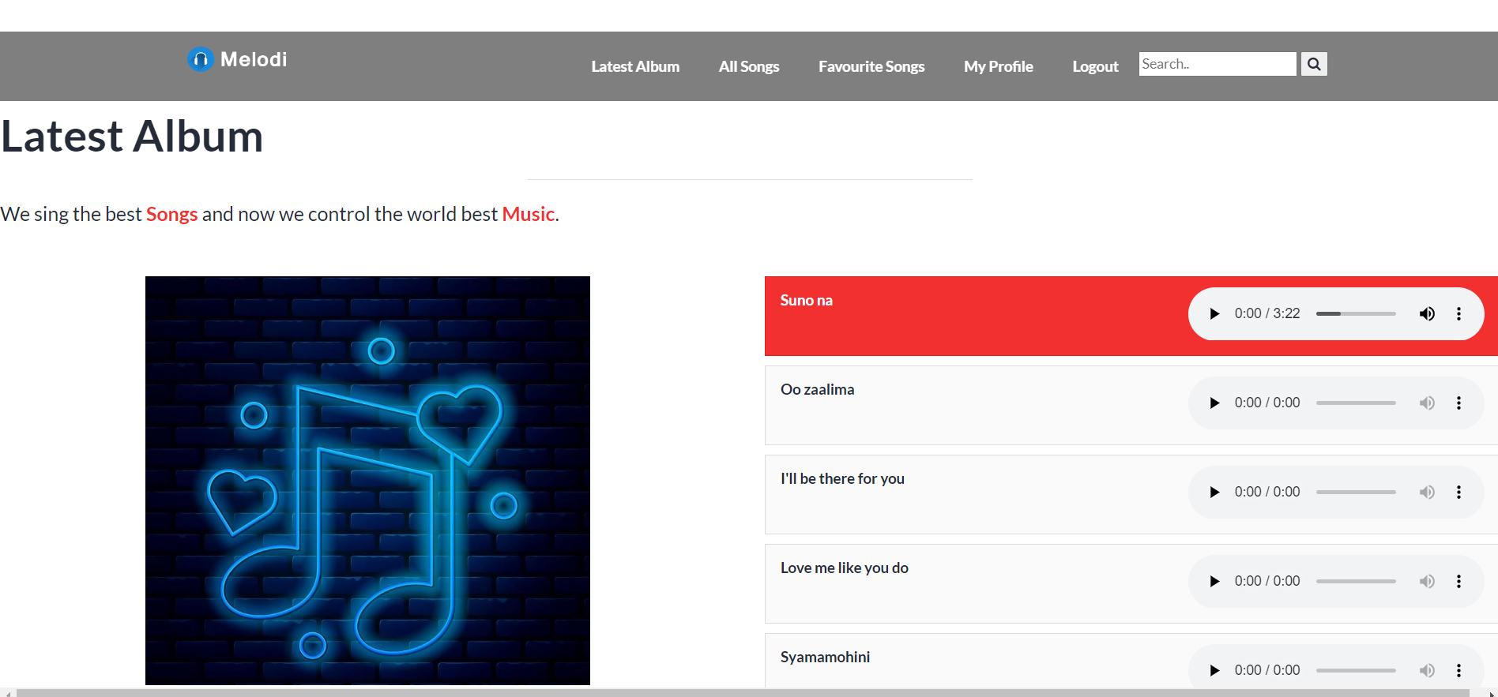

**ALL SONGS**

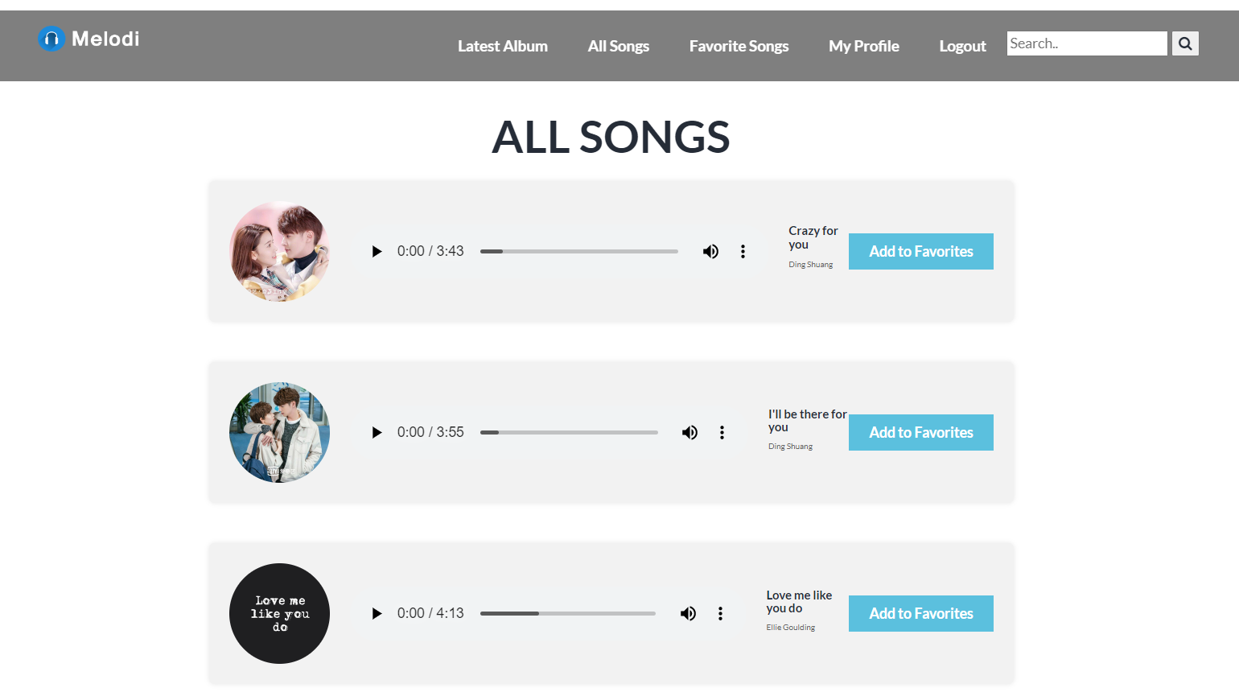

**FAVORITE SONGS PAGE**



**MY PROFILE PAGE**

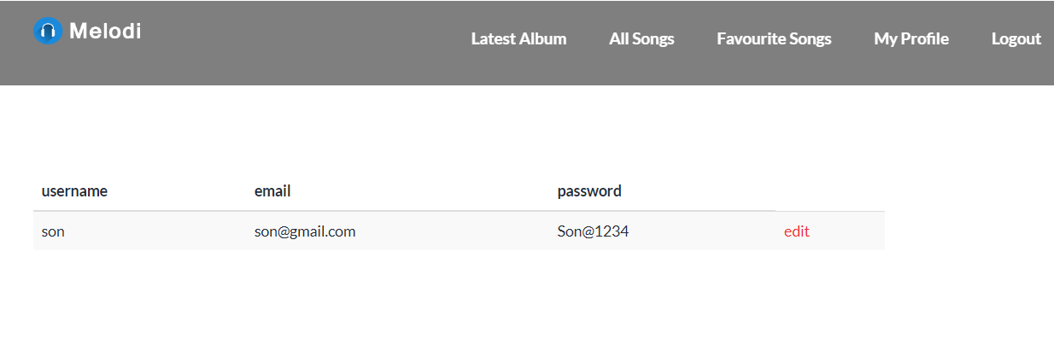

**UPDATE PROFILE PAGE**

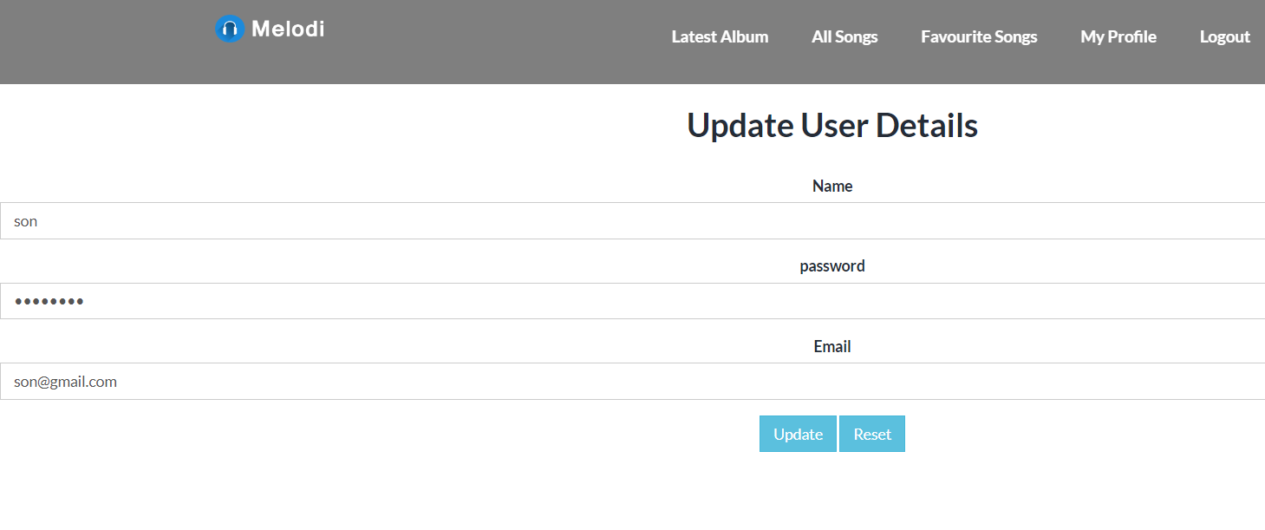

**SEARCH RESULT PAGE**

